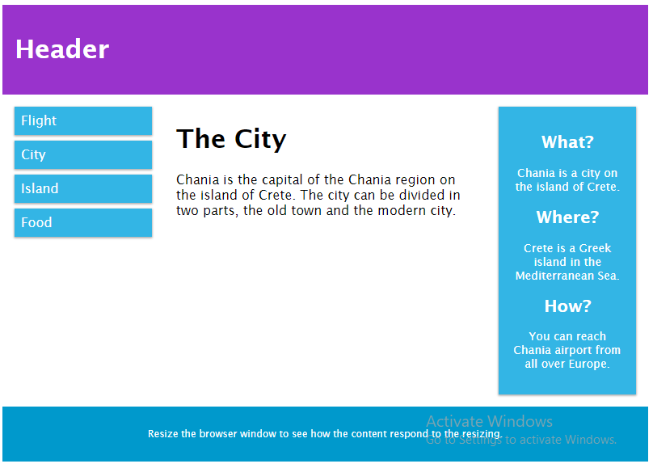

<!DOCTYPE html>

<html>

<head>

<meta name="viewport" content="width=device-width, initial-scale=1.0">

<style>

* {

box-sizing: border-box;

}

.row::after {

content: "";

clear: both;

display: table;

}

[class*="col-"] {

float: left;

padding: 15px;

}

html {

font-family: "Lucida Sans", sans-serif;

}

.header {

background-color: #9933cc;

color: #ffffff;

padding: 15px;

}

.menu ul {

list-style-type: none;

margin: 0;

padding: 0;

}

.menu li {

padding: 8px;

margin-bottom: 7px;

background-color: #33b5e5;

color: #ffffff;

box-shadow: 0 1px 3px rgba(0,0,0,0.12), 0 1px 2px rgba(0,0,0,0.24);

}

.menu li:hover {

background-color: #0099cc;

}

.aside {

background-color: #33b5e5;

padding: 15px;

color: #ffffff;

text-align: center;

font-size: 14px;

box-shadow: 0 1px 3px rgba(0,0,0,0.12), 0 1px 2px rgba(0,0,0,0.24);

}

.footer {

background-color: #0099cc;

color: #ffffff;

text-align: center;

font-size: 12px;

padding: 15px;

}

/* For mobile phones: */

[class*="col-"] {

width: 100%;

}

@media only screen and (min-width: 600px) {

/* For tablets: */

.col-s-1 {width: 8.33%;}

.col-s-2 {width: 16.66%;}

.col-s-3 {width: 25%;}

.col-s-4 {width: 33.33%;}

.col-s-5 {width: 41.66%;}

.col-s-6 {width: 50%;}

.col-s-7 {width: 58.33%;}

.col-s-8 {width: 66.66%;}

.col-s-9 {width: 75%;}

.col-s-10 {width: 83.33%;}

.col-s-11 {width: 91.66%;}

.col-s-12 {width: 100%;}

}

@media only screen and (min-width: 768px) {

/* For desktop: */

.col-1 {width: 8.33%;}

.col-2 {width: 16.66%;}

.col-3 {width: 25%;}

.col-4 {width: 33.33%;}

.col-5 {width: 41.66%;}

.col-6 {width: 50%;}

.col-7 {width: 58.33%;}

.col-8 {width: 66.66%;}

.col-9 {width: 75%;}

.col-10 {width: 83.33%;}

.col-11 {width: 91.66%;}

.col-12 {width: 100%;}

}

</style>

</head>

<body>

<div class="header">

<h1>Header</h1>

</div>

<div class="row">

<div class="col-3 col-s-3 menu">

<ul>

<li> Flight</li>

<li> City</li>

<li> Island</li>

<li> Food</li>

</ul>

</div>

<div class="col-6 col-s-9">

<h1>The City</h1>

<p>Chania is the capital of the Chania region on the island of Crete. The city can be divided in two parts, the old town and the modern city.</p>

</div>

<div class="col-3 col-s-12">

<div class="aside">

<h2>What?</h2>

<p>Chania is a city on the island of Crete.</p>

<h2>Where?</h2>

<p>Crete is a Greek island in the Mediterranean Sea.</p>

<h2>How?</h2>

<p>You can reach Chania airport from all over Europe.</p>

</div>

</div>

</div>

<div class="footer">

<p>Resize the browser window to see how the content respond to the resizing.</p>

</div>

</body>

</html>

What is The Viewport?

The viewport is the user's visible area of a web page.

The viewport varies with the device, and will be smaller on a mobile phone than on a computer screen.

Before tablets and mobile phones, web pages were designed only for computer screens, and it was common for web pages to have a static design and a fixed size.

Then, when we started surfing the internet using tablets and mobile phones, fixed size web pages were too large to fit the viewport. To fix this, browsers on those devices scaled down the entire web page to fit the screen

Setting The Viewport

HTML5 introduced a method to let web designers take control over the viewport, through the <meta> tag.

You should include the following <meta> viewport element in all your web pages:

<meta name="viewport" content="width=device-width, initial-scale=1.0">

A <meta> viewport element gives the browser instructions on how to control the page's dimensions and scaling.

The width=device-width part sets the width of the page to follow the screen-width of the device (which will vary depending on the device).

The initial-scale=1.0 part sets the initial zoom level when the page is first loaded by the browser.

## Size Content to The Viewport

Users are used to scroll websites vertically on both desktop and mobile devices - but not horizontally!

So, if the user is forced to scroll horizontally, or zoom out, to see the whole web page it results in a poor user experience.

Some additional rules to follow:

**1. Do NOT use large fixed width elements -**For example, if an image is displayed at a width wider than the viewport it can cause the viewport to scroll horizontally. Remember to adjust this content to fit within the width of the viewport.

**2. Do NOT let the content rely on a particular viewport width to render well** - Since screen dimensions and width in CSS pixels vary widely between devices, content should not rely on a particular viewport width to render well.

**3. Use CSS media queries to apply different styling for small and large screens** - Setting large absolute CSS widths for page elements will cause the element to be too wide for the viewport on a smaller device. Instead, consider using relative width values, such as width: 100%. Also, be careful of using large absolute positioning values. It may cause the element to fall outside the viewport on small devices.

## What is a Grid-View?

Many web pages are based on a grid-view, which means that the page is divided into columns:

## Building a Responsive Grid-View

Lets start building a responsive grid-view.

First ensure that all HTML elements have the box-sizing property set to border-box. This makes sure that the padding and border are included in the total width and height of the elements.

Add the following code in your CSS:

* {  
  box-sizing: border-box;  
}

Read more about the box-sizing property in our [CSS Box Sizing](https://www.w3schools.com/css/css3_box-sizing.asp) chapter.

The following example shows a simple responsive web page, with two columns:

25%

75%

### **Example**

.menu {  
  width: 25%;  
  float: left;  
}  
.main {  
  width: 75%;  
  float: left;  
}

The example above is fine if the web page only contains two columns.

However, we want to use a responsive grid-view with 12 columns, to have more control over the web page.

First we must calculate the percentage for one column: 100% / 12 columns = 8.33%.

Then we make one class for each of the 12 columns, class="col-" and a number defining how many columns the section should span:

### **CSS:**

.col-1 {width: 8.33%;}  
.col-2 {width: 16.66%;}  
.col-3 {width: 25%;}  
.col-4 {width: 33.33%;}  
.col-5 {width: 41.66%;}  
.col-6 {width: 50%;}  
.col-7 {width: 58.33%;}  
.col-8 {width: 66.66%;}  
.col-9 {width: 75%;}  
.col-10 {width: 83.33%;}  
.col-11 {width: 91.66%;}  
.col-12 {width: 100%;}

All these columns should be floating to the left, and have a padding of 15px:

### **CSS:**

[class*="col-"] {  
  float: left;  
  padding: 15px;  
  border: 1px solid red;  
}

Each row should be wrapped in a <div>. The number of columns inside a row should always add up to 12:

### **HTML:**

<div class="row">  
  <div class="col-3">...</div> <!-- 25% -->  
  <div class="col-9">...</div> <!-- 75% -->  
</div>

The columns inside a row are all floating to the left, and are therefore taken out of the flow of the page, and other elements will be placed as if the columns do not exist. To prevent this, we will add a style that clears the flow:

### **CSS:**

.row::after {  
  content: "";  
  clear: both;  
  display: table;  
}

We also want to add some styles and colors to make it look better:

### **Example**

html {  
  font-family: "Lucida Sans", sans-serif;  
}  
  
.header {  
  background-color: #9933cc;  
  color: #ffffff;  
  padding: 15px;  
}  
  
.menu ul {  
  list-style-type: none;  
  margin: 0;  
  padding: 0;  
}  
  
.menu li {  
  padding: 8px;  
  margin-bottom: 7px;  
  background-color :#33b5e5;  
  color: #ffffff;  
  box-shadow: 0 1px 3px rgba(0,0,0,0.12), 0 1px 2px rgba(0,0,0,0.24);  
}  
  
.menu li:hover {  
  background-color: #0099cc;  
}

# **Media Queries**

## What is a Media Query?

Media query is a CSS technique introduced in CSS3.

It uses the @media rule to include a block of CSS properties only if a certain condition is true.

### **Example**

If the browser window is 600px or smaller, the background color will be lightblue:

@media only screen and (max-width: 600px) {  
  body {  
    background-color: lightblue;  
  }  
}

## Add a Breakpoint

Earlier in this tutorial we made a web page with rows and columns, and it was responsive, but it did not look good on a small screen.

Media queries can help with that. We can add a breakpoint where certain parts of the design will behave differently on each side of the breakpoint.

**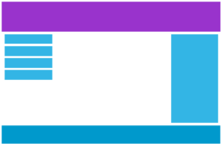   
Desktop**

**   
Phone**

Use a media query to add a breakpoint at 768px:

### **Example**

When the screen (browser window) gets smaller than 768px, each column should have a width of 100%:

/* For desktop: */  
.col-1 {width: 8.33%;}  
.col-2 {width: 16.66%;}  
.col-3 {width: 25%;}  
.col-4 {width: 33.33%;}  
.col-5 {width: 41.66%;}  
.col-6 {width: 50%;}  
.col-7 {width: 58.33%;}  
.col-8 {width: 66.66%;}  
.col-9 {width: 75%;}  
.col-10 {width: 83.33%;}  
.col-11 {width: 91.66%;}  
.col-12 {width: 100%;}  
  
@media only screen and (max-width: 768px) {  
  /* For mobile phones: */  
  [class*="col-"] {  
    width: 100%;  
  }  
}

## Always Design for Mobile First

Mobile First means designing for mobile before designing for desktop or any other device (This will make the page display faster on smaller devices).

This means that we must make some changes in our CSS.

Instead of changing styles when the width gets smaller than 768px, we should change the design when the width gets larger than 768px. This will make our design Mobile First:

### **Example**

/* For mobile phones: */  
[class*="col-"] {  
  width: 100%;  
}  
  
@media only screen and (min-width: 768px) {  
  /* For desktop: */  
  .col-1 {width: 8.33%;}  
  .col-2 {width: 16.66%;}  
  .col-3 {width: 25%;}  
  .col-4 {width: 33.33%;}  
  .col-5 {width: 41.66%;}  
  .col-6 {width: 50%;}  
  .col-7 {width: 58.33%;}  
  .col-8 {width: 66.66%;}  
  .col-9 {width: 75%;}  
  .col-10 {width: 83.33%;}  
  .col-11 {width: 91.66%;}  
  .col-12 {width: 100%;}  
}

## Another Breakpoint

You can add as many breakpoints as you like.

We will also insert a breakpoint between tablets and mobile phones.

**   
Desktop**

**   
Tablet**

**   
Phone**

We do this by adding one more media query (at 600px), and a set of new classes for devices larger than 600px (but smaller than 768px):

### **Example**

Note that the two sets of classes are almost identical, the only difference is the name (col- and col-s-):

/* For mobile phones: */  
[class*="col-"] {  
  width: 100%;  
}  
  
@media only screen and (min-width: 600px) {  
  /* For tablets: */  
  .col-s-1 {width: 8.33%;}  
  .col-s-2 {width: 16.66%;}  
  .col-s-3 {width: 25%;}  
  .col-s-4 {width: 33.33%;}  
  .col-s-5 {width: 41.66%;}  
  .col-s-6 {width: 50%;}  
  .col-s-7 {width: 58.33%;}  
  .col-s-8 {width: 66.66%;}  
  .col-s-9 {width: 75%;}  
  .col-s-10 {width: 83.33%;}  
  .col-s-11 {width: 91.66%;}  
  .col-s-12 {width: 100%;}  
}  
  
@media only screen and (min-width: 768px) {  
  /* For desktop: */  
  .col-1 {width: 8.33%;}  
  .col-2 {width: 16.66%;}  
  .col-3 {width: 25%;}  
  .col-4 {width: 33.33%;}  
  .col-5 {width: 41.66%;}  
  .col-6 {width: 50%;}  
  .col-7 {width: 58.33%;}  
  .col-8 {width: 66.66%;}  
  .col-9 {width: 75%;}  
  .col-10 {width: 83.33%;}  
  .col-11 {width: 91.66%;}  
  .col-12 {width: 100%;}  
}

It might seem odd that we have two sets of identical classes, but it gives us the opportunity in HTML, to decide what will happen with the columns at each breakpoint:

### **HTML Example**

**For desktop:**

The first and the third section will both span 3 columns each. The middle section will span 6 columns.

**For tablets:**

The first section will span 3 columns, the second will span 9, and the third section will be displayed below the first two sections, and it will span 12 columns:

<div class="row">  
  <div class="col-3 col-s-3">...</div>  
  <div class="col-6 col-s-9">...</div>  
  <div class="col-3 col-s-12">...</div>  
</div>

## Typical Device Breakpoints

There are tons of screens and devices with different heights and widths, so it is hard to create an exact breakpoint for each device. To keep things simple you could target five groups:

### **Example**

/* Extra small devices (phones, 600px and down) */  
@media only screen and (max-width: 600px) {...}   
  
/* Small devices (portrait tablets and large phones, 600px and up) */  
@media only screen and (min-width: 600px) {...}   
  
/* Medium devices (landscape tablets, 768px and up) */  
@media only screen and (min-width: 768px) {...}   
  
/* Large devices (laptops/desktops, 992px and up) */  
@media only screen and (min-width: 992px) {...}   
  
/* Extra large devices (large laptops and desktops, 1200px and up) */  
@media only screen and (min-width: 1200px) {...}

## Orientation: Portrait / Landscape

Media queries can also be used to change layout of a page depending on the orientation of the browser.

You can have a set of CSS properties that will only apply when the browser window is wider than its height, a so called "Landscape" orientation:

### **Example**

The web page will have a lightblue background if the orientation is in landscape mode:

@media only screen and (orientation: landscape) {  
  body {  
    background-color: lightblue;  
  }  
}

## Hide Elements With Media Queries

Another common use of media queries, is to hide elements on different screen sizes:

I will be hidden on small screens.

### **Example**

/* If the screen size is 600px wide or less, hide the element */  
@media only screen and (max-width: 600px) {  
  div.example {  
    display: none;  
  }  
}

## Change Font Size With Media Queries

You can also use media queries to change the font size of an element on different screen sizes:

# **Variable Font Size.**

### **Example**

/* If the screen size is 601px or more, set the font-size of <div> to 80px */  
@media only screen and (min-width: 601px) {  
  div.example {  
    font-size: 80px;  
  }  
}  
  
/* If the screen size is 600px or less, set the font-size of <div> to 30px */  
@media only screen and (max-width: 600px) {  
  div.example {  
    font-size: 30px;  
  }  
}